Logos Cafe - Update Aug 2019

Just a quick update on our progress with our refurbishment plans.

After finding out that we are now required to obtain planning permission via the archaeological departments in Corfu, Ioannina and most probably Athens(!) we have been seeking the advice of the local planning department as to the process and approach we should take. We have been very blessed (a very specific answer to prayer) by the assistance of the staff there who have looked at our plans and aspirations and looked at what is likely to be approved and been very hands on in shaping the refurbishment proposal in such a way that it is likely to be favourably appraised! The consequence of this is that the following plans are in the process of application as we go to print this month. So, what is being requested?

The following spot the difference diagrams may help!

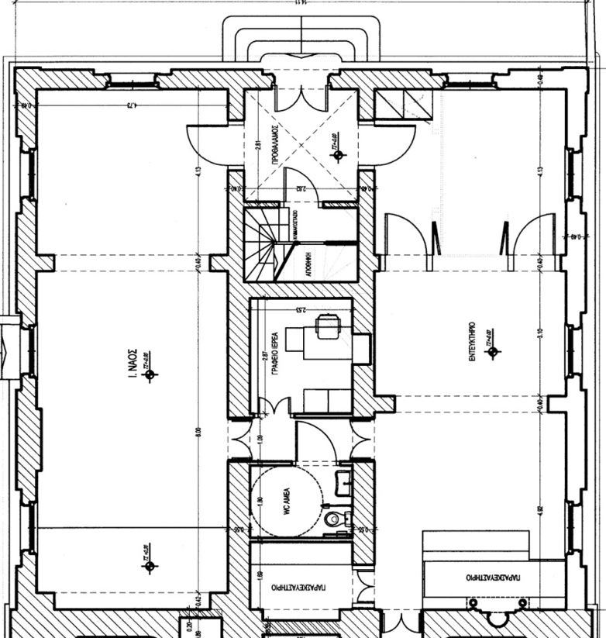

· The whole of the current library and study will be opened up to allow one large room with a bar/serving counter on the far wall next to the new kitchen to the left. In addition, there will be door panelling enabling the rooms to be split in two if desired, creating greater flexibility.
· A small office will be located where the kitchen currently is.
· The two toilets will be replaced with a single disabled toilet with baby changing facilities.
· There will be a corridor outside the new office connecting the Cafe area with the church.
· The whole of the central area will have a new roof.

The view of the panelling in the cafe area when closed would look like the left hand picture.

The right hand picture shows the panelling across the room which is capable of being fully opened and the shape of the new roof.

This design, in combination with the accessibility developments outside the building, will create the open, welcoming and more flexible space that we are praying will enable the new mission opportunities at the heart of the project.

Please keep praying and we’ll keep you posted!!

